1. Approximately how long is a C−C single bond of an alkane?
 | a. | 111 pm
 | b. | 134 pm
 | c. | 142 pm
 | d. | 153 pm

ANSWER: | d
POINTS: | 1
QUESTION TYPE: | Multiple Choice
HAS VARIABLES: | False
DATE CREATED: | 3/12/2015 3:24 PM
DATE MODIFIED: | 3/12/2015 3:24 PM

2. What is the approximate C−C−C bond angle in propane?
 | a. | 90°
 | b. | 109°
 | c. | 120°
 | d. | 180°

ANSWER: | b
POINTS: | 1
QUESTION TYPE: | Multiple Choice
HAS VARIABLES: | False
DATE CREATED: | 3/12/2015 3:24 PM
DATE MODIFIED: | 3/12/2015 3:24 PM

3. What is the name of the linear hydrocarbon with the molecular formula C₇H₁₆?
 | a. | hexane
 | b. | heptane
 | c. | decane
 | d. | undecane

ANSWER: | b
POINTS: | 1
QUESTION TYPE: | Multiple Choice
HAS VARIABLES: | False
DATE CREATED: | 3/12/2015 3:24 PM
DATE MODIFIED: | 3/12/2015 3:24 PM

4. What is the name of the linear hydrocarbon with the molecular formula C₁₁H₂₄?
 | a. | heptane
 | b. | decane
 | c. | undecane
 | d. | eicosane

ANSWER: | c
POINTS: | 1
QUESTION TYPE: | Multiple Choice
HAS VARIABLES: | False
DATE CREATED: | 3/12/2015 3:24 PM
DATE MODIFIED: | 3/12/2015 3:24 PM

5. How many hydrogen atoms are there in nonane, the linear hydrocarbon with nine carbon atoms?
 | a. | 16
 | b. | 18
 | c. | 20
 | d. | 22

ANSWER: | c
POINTS: | 1
QUESTION TYPE: | Multiple Choice
HAS VARIABLES: | False
DATE CREATED: | 3/12/2015 3:24 PM
DATE MODIFIED: | 3/12/2015 3:24 PM

6. How many hydrogen atoms are there in dodecane, the linear hydrocarbon with twelve carbon atoms?
 | a. | 12
 | b. | 20
 | c. | 24
 | d. | 26

ANSWER: | d
POINTS: | 1
QUESTION TYPE: | Multiple Choice
HAS VARIABLES: | False
DATE CREATED: | 3/12/2015 3:24 PM
DATE MODIFIED: | 3/12/2015 3:24 PM

7. How many constitutional isomers are there with the molecular formula C₄H₁₀?
 | a. | 2
 | b. | 3
 | c. | 4
 | d. | 5

ANSWER: | a
POINTS: | 1
QUESTION TYPE: | Multiple Choice
HAS VARIABLES: | False
DATE CREATED: | 3/12/2015 3:24 PM
DATE MODIFIED: | 3/12/2015 3:24 PM

8. How many constitutional isomers are there with the molecular formula C₅H₁₂?
 | a. | 2
 | b. | 3
 | c. | 4
 | d. | 5

ANSWER: | b
POINTS: | 1
QUESTION TYPE: | Multiple Choice
HAS VARIABLES: | False
DATE CREATED: | 3/12/2015 3:24 PM
DATE MODIFIED: | 3/12/2015 3:24 PM

9. How many constitutional isomers are there with the molecular formula C₆H₁₄?
 | a. | 3
 | b. | 4
 | c. | 5
 | d. | 8

ANSWER: | c
POINTS: | 1
QUESTION TYPE: | Multiple Choice
HAS VARIABLES: | False
DATE CREATED: | 3/12/2015 3:24 PM
DATE MODIFIED: | 3/12/2015 3:24 PM

10. What is the IUPAC name of the following compound?
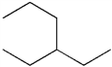
 | a. | 3-propylpentane
 | b. | 1,1-diethylpropane
 | c. | 3-ethylhexane
 | d. | isooctane

ANSWER: | c
POINTS: | 1
QUESTION TYPE: | Multiple Choice
HAS VARIABLES: | False
DATE CREATED: | 3/12/2015 3:24 PM
DATE MODIFIED: | 3/12/2015 3:24 PM

11. What is the IUPAC name of the following compound?
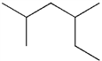
 | a. | 2-ethyl-4-methylpentane
 | b. | 2,4-dimethylhexane
 | c. | 3,5-dimethylhexane
 | d. | 1,1,3-trimethylpentane

ANSWER: | b
POINTS: | 1
QUESTION TYPE: | Multiple Choice
HAS VARIABLES: | False
DATE CREATED: | 3/12/2015 3:24 PM
DATE MODIFIED: | 3/12/2015 3:24 PM

12. What is the IUPAC name of the following compound?
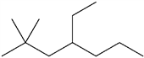
 | a. | 2,2-dimethyl-4-ethylheptane
 | b. | 4-ethyl-2,2-dimethyl-heptane
 | c. | 6,6-dimethyl-4-ethylheptane
 | d. | 4-ethyl-6,6-dimethyl-heptane

ANSWER: | b
POINTS: | 1
QUESTION TYPE: | Multiple Choice
HAS VARIABLES: | False
DATE CREATED: | 3/12/2015 3:24 PM
DATE MODIFIED: | 3/12/2015 3:24 PM

13. What is the IUPAC name of the following compound?
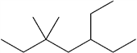
 | a. | 5,5-dimethyl-3-ethylheptane
 | b. | 5-ethyl-3,3-dimethyl-heptane
 | c. | 3,3-dimethyl-5-ethylheptane
 | d. | 3-ethyl-5,5-dimethyl-heptane

ANSWER: | d
POINTS: | 1
QUESTION TYPE: | Multiple Choice
HAS VARIABLES: | False
DATE CREATED: | 3/12/2015 3:24 PM
DATE MODIFIED: | 3/12/2015 3:24 PM

14. What is the IUPAC name of the following compound?
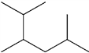
 | a. | 2-isopropyl-5-methylpentane
 | b. | 5-isopropyl-2-methylpentane
 | c. | 2,3,5-trimethylhexane
 | d. | 1,2-diisopropylpropane

ANSWER: | c
POINTS: | 1
QUESTION TYPE: | Multiple Choice
HAS VARIABLES: | False
DATE CREATED: | 3/12/2015 3:24 PM
DATE MODIFIED: | 3/12/2015 3:24 PM

15. What is the IUPAC name of the following compound?
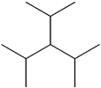
 | a. | 2,4-dimethyl-3-isopropyl-pentane
 | b. | 3-isopropyl-1,5-dimethylpentane
 | c. | 3-isopropyl-2,4-dimethylpentane
 | d. | triisopropylmethane

ANSWER: | c
POINTS: | 1
QUESTION TYPE: | Multiple Choice
HAS VARIABLES: | False
DATE CREATED: | 3/12/2015 3:24 PM
DATE MODIFIED: | 3/12/2015 3:24 PM

16. Which of the following compounds has 1°, 2°, 3° and 4° carbon atoms?
 | a. | hexane
 | b. | 2-methylhexane
 | c. | 2,2-dimethylhexane
 | d. | 2,2,3-trimethylhexane

ANSWER: | d
POINTS: | 1
QUESTION TYPE: | Multiple Choice
HAS VARIABLES: | False
DATE CREATED: | 3/12/2015 3:24 PM
DATE MODIFIED: | 3/12/2015 3:24 PM

17. Which of the following compounds has only 1° and 3° carbon atoms?
 | a. | hexane
 | b. | 2-methylpentane
 | c. | 3-methylpentane
 | d. | 2,3-dimethylbutane

ANSWER: | d
POINTS: | 1
QUESTION TYPE: | Multiple Choice
HAS VARIABLES: | False
DATE CREATED: | 3/12/2015 3:24 PM
DATE MODIFIED: | 3/12/2015 3:24 PM

18. What is the correct assignment of common names for the following molecules?
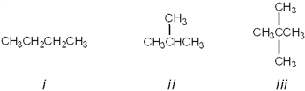
 | a. | i = butane; ii = neopentane; iii = isopentane
 | b. | i = neobutane; ii = isobutane; iii = pentane
 | c. | i = butane; ii = isobutane; iii = isopentane
 | d. | i = butane; ii = isobutane; iii = neopentane

ANSWER: | d
POINTS: | 1
QUESTION TYPE: | Multiple Choice
HAS VARIABLES: | False
DATE CREATED: | 3/12/2015 3:24 PM
DATE MODIFIED: | 3/12/2015 3:24 PM

19. What is the correct assignment of common names for the following molecules?
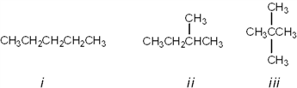
 | a. | i = pentane; ii = isopentane; iii = neopentane
 | b. | i = neopentane; ii = isopentane; iii = pentane
 | c. | i = pentane; ii = neopentane; iii = isopentane
 | d. | i = neopentane; ii = pentane; iii = isopentane

ANSWER: | a
POINTS: | 1
QUESTION TYPE: | Multiple Choice
HAS VARIABLES: | False
DATE CREATED: | 3/12/2015 3:24 PM
DATE MODIFIED: | 3/12/2015 3:24 PM

20. What is the IUPAC name of the following compound?
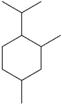
 | a. | 1-isopropyl-4,6-dimethylcyclohexane
 | b. | 1-isopropyl-2,4-dimethylcyclohexane
 | c. | 4-isopropyl-1,3-dimethylcyclohexane
 | d. | 4-isopropyl-1,5-dimethylcyclohexane

ANSWER: | b
POINTS: | 1
QUESTION TYPE: | Multiple Choice
HAS VARIABLES: | False
DATE CREATED: | 3/12/2015 3:24 PM
DATE MODIFIED: | 3/12/2015 3:24 PM

21. What is the IUPAC name of the following compound?
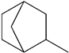
 | a. | 1-methylbicyclo[2.2.1]heptane
 | b. | 2-methylbicyclo[2.2.1]heptane
 | c. | 3-methylbicyclo[2.2.1]heptane
 | d. | 4-methylbicyclo[2.2.1]heptane

ANSWER: | b
POINTS: | 1
QUESTION TYPE: | Multiple Choice
HAS VARIABLES: | False
DATE CREATED: | 3/12/2015 3:24 PM
DATE MODIFIED: | 3/12/2015 3:24 PM

22. What is the IUPAC name of the following compound?
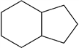
 | a. | bicyclo[4.3]nonane
 | b. | bicyclo[4.3.0]nonane
 | c. | bicyclo[6.5]nonane
 | d. | bicyclo[6.5.0]nonane

ANSWER: | b
POINTS: | 1
QUESTION TYPE: | Multiple Choice
HAS VARIABLES: | False
DATE CREATED: | 3/12/2015 3:24 PM
DATE MODIFIED: | 3/12/2015 3:24 PM

23. What is the IUPAC name for the following compound?
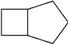
 | a. | cycloheptane
 | b. | bicyclo[3.2.0]heptane
 | c. | bicyclo[5.4]heptane
 | d. | cyclobutylcyclopentane

ANSWER: | b
POINTS: | 1
QUESTION TYPE: | Multiple Choice
HAS VARIABLES: | False
DATE CREATED: | 3/12/2015 3:24 PM
DATE MODIFIED: | 3/12/2015 3:24 PM

24. What is the IUPAC name for the following compound?
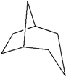
 | a. | bicyclo[5.4.3]octane
 | b. | bicyclo[3.2.1]octane
 | c. | bicyclo[3.2.1]hexane
 | d. | bicyclo[2.2.1]octane

ANSWER: | b
POINTS: | 1
QUESTION TYPE: | Multiple Choice
HAS VARIABLES: | False
DATE CREATED: | 3/12/2015 3:24 PM
DATE MODIFIED: | 3/12/2015 3:24 PM

25. Which of the following Newman projections does not represent 2-methylhexane?
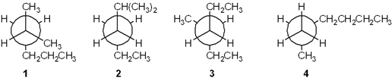
 | a. | 1
 | b. | 2
 | c. | 3
 | d. | 4

ANSWER: | c
POINTS: | 1
QUESTION TYPE: | Multiple Choice
HAS VARIABLES: | False
DATE CREATED: | 3/12/2015 3:24 PM
DATE MODIFIED: | 3/12/2015 3:24 PM

26. Which of the following Newman projections represents 2,4-dimethylpentane?
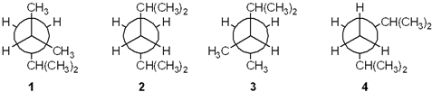
 | a. | 1
 | b. | 2
 | c. | 3
 | d. | 4

ANSWER: | a
POINTS: | 1
QUESTION TYPE: | Multiple Choice
HAS VARIABLES: | False
DATE CREATED: | 3/12/2015 3:24 PM
DATE MODIFIED: | 3/12/2015 3:24 PM

27. Which of the following Newman projections represents the most stable conformation of 2,3-dimethylbutane?
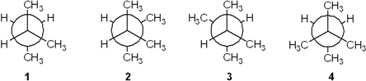
 | a. | 1
 | b. | 2
 | c. | 3
 | d. | 4

ANSWER: | c
POINTS: | 1
QUESTION TYPE: | Multiple Choice
HAS VARIABLES: | False
DATE CREATED: | 3/12/2015 3:24 PM
DATE MODIFIED: | 3/12/2015 3:24 PM

28. Which of the following Newman projections represents the most stable conformation of 2-methylbutane?
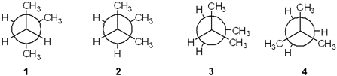
 | a. | 1
 | b. | 2
 | c. | 3
 | d. | 4

ANSWER: | a
POINTS: | 1
QUESTION TYPE: | Multiple Choice
HAS VARIABLES: | False
DATE CREATED: | 3/12/2015 3:24 PM
DATE MODIFIED: | 3/12/2015 3:24 PM

29. Which of the following cycloalkanes has the most ring strain?
 | a. | cyclopropane
 | b. | cyclobutane
 | c. | cyclopentane
 | d. | cyclohexane

ANSWER: | a
POINTS: | 1
QUESTION TYPE: | Multiple Choice
HAS VARIABLES: | False
DATE CREATED: | 3/12/2015 3:24 PM
DATE MODIFIED: | 3/12/2015 3:24 PM

30. Which of the following cycloalkanes has the least ring strain?
 | a. | cyclopropane
 | b. | cyclopentane
 | c. | cyclohexane
 | d. | cycloheptane

ANSWER: | c
POINTS: | 1
QUESTION TYPE: | Multiple Choice
HAS VARIABLES: | False
DATE CREATED: | 3/12/2015 3:24 PM
DATE MODIFIED: | 3/12/2015 3:24 PM

31. Which of the following structures represents trans-1,3-dimethylcyclohexane?
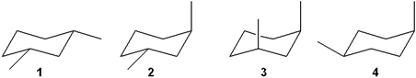
 | a. | 1
 | b. | 2
 | c. | 3
 | d. | 4

ANSWER: | b
POINTS: | 1
QUESTION TYPE: | Multiple Choice
HAS VARIABLES: | False
DATE CREATED: | 3/12/2015 3:24 PM
DATE MODIFIED: | 3/12/2015 3:24 PM

32. Which of the following structures represents trans-1,2-dimethylcyclohexane?
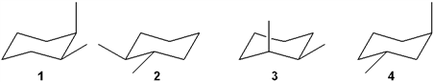
 | a. | 1
 | b. | 2
 | c. | 3
 | d. | 4

ANSWER: | b
POINTS: | 1
QUESTION TYPE: | Multiple Choice
HAS VARIABLES: | False
DATE CREATED: | 3/12/2015 3:24 PM
DATE MODIFIED: | 3/12/2015 3:24 PM

33. Which of the following is the most stable conformation of cis-1-isopropyl-3-methylcyclohexane?
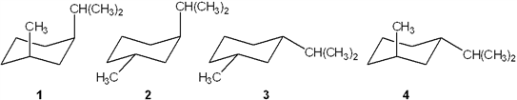
 | a. | 1
 | b. | 2
 | c. | 3
 | d. | 4

ANSWER: | c
POINTS: | 1
QUESTION TYPE: | Multiple Choice
HAS VARIABLES: | False
DATE CREATED: | 3/12/2015 3:24 PM
DATE MODIFIED: | 3/12/2015 3:24 PM

34. Which of the following is the most stable conformation of trans-1-ethyl-3-methylcyclohexane?
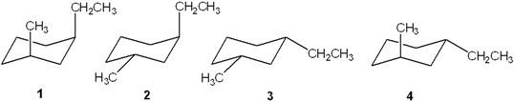
 | a. | 1
 | b. | 2
 | c. | 3
 | d. | 4

ANSWER: | d
POINTS: | 1
QUESTION TYPE: | Multiple Choice
HAS VARIABLES: | False
DATE CREATED: | 3/12/2015 3:24 PM
DATE MODIFIED: | 3/12/2015 3:24 PM

35. Which of the following alkanes has the highest boiling point?
 | a. | propane
 | b. | butane
 | c. | pentane
 | d. | hexane

ANSWER: | d
POINTS: | 1
QUESTION TYPE: | Multiple Choice
HAS VARIABLES: | False
DATE CREATED: | 3/12/2015 3:24 PM
DATE MODIFIED: | 3/12/2015 3:24 PM

36. Which of the following alkanes has the highest boiling point?
 | a. | 2,3-dimethylbutane
 | b. | 2-methylpentane
 | c. | 3-methylpentane
 | d. | hexane

ANSWER: | d
POINTS: | 1
QUESTION TYPE: | Multiple Choice
HAS VARIABLES: | False
DATE CREATED: | 3/12/2015 3:24 PM
DATE MODIFIED: | 3/12/2015 3:24 PM

37. What is the IUPAC name of the following compound?
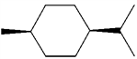
 | a. | trans-1-isopropyl-4-methylcyclohexane
 | b. | cis-1-isopropyl-4-methylcyclohexane
 | c. | cis-2-isopropyl-5-methylcyclohexane
 | d. | cis-1-tert-butyl-4-methylcyclohexane

ANSWER: | b
POINTS: | 1
QUESTION TYPE: | Multiple Choice
HAS VARIABLES: | False
DATE CREATED: | 3/12/2015 3:24 PM
DATE MODIFIED: | 3/12/2015 3:24 PM

38. What is the IUPAC name of the following compound?
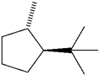
 | a. | trans-1-isopropyl-4-methylcyclopentane
 | b. | cis-1-tert-butyl-2-methylcyclopentane
 | c. | trans-1-tert-butyl-2-methylcyclopentane
 | d. | cis-1-isopropyl-2-methylcyclopentane

ANSWER: | c
POINTS: | 1
QUESTION TYPE: | Multiple Choice
HAS VARIABLES: | False
DATE CREATED: | 3/12/2015 3:24 PM
DATE MODIFIED: | 3/12/2015 3:24 PM

39. Which one of the following structures represents a different compound from the other three?
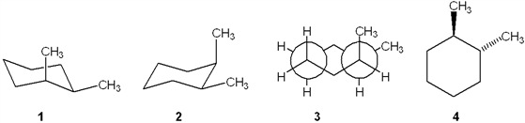
 | a. | 1
 | b. | 2
 | c. | 3
 | d. | 4

ANSWER: | d
POINTS: | 1
QUESTION TYPE: | Multiple Choice
HAS VARIABLES: | False
DATE CREATED: | 3/12/2015 3:24 PM
DATE MODIFIED: | 3/12/2015 3:24 PM

40. Which one of the following structures represents a different compound from the other three?
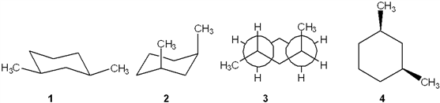
 | a. | 1
 | b. | 2
 | c. | 3
 | d. | 4

ANSWER: | c
POINTS: | 1
QUESTION TYPE: | Multiple Choice
HAS VARIABLES: | False
DATE CREATED: | 3/12/2015 3:24 PM
DATE MODIFIED: | 3/12/2015 3:24 PM

41. In which of the following compounds are all of the carbon atoms in the same plane?
 | a. | cyclopropane
 | b. | cyclobutane
 | c. | cyclopentane
 | d. | cyclohexane

ANSWER: | a
POINTS: | 1
QUESTION TYPE: | Multiple Choice
HAS VARIABLES: | False
DATE CREATED: | 3/12/2015 3:24 PM
DATE MODIFIED: | 3/12/2015 3:24 PM

42. Which of the following compounds can adopt a chair conformation in which there are no axial methyl groups?
 | a. | 1,1-dimethylcyclohexane
 | b. | cis-1,2-dimethylcyclohexane
 | c. | trans-1,2-dimethylcyclohexane
 | d. | cis-1,3-dimethylcyclohexane

ANSWER: | c
POINTS: | 1
QUESTION TYPE: | Multiple Choice
HAS VARIABLES: | False
DATE CREATED: | 3/12/2015 3:24 PM
DATE MODIFIED: | 3/12/2015 3:24 PM

43. Which of the following compounds can adopt a chair conformation in which there are no axial methyl groups?
 | a. | cis-1,2-dimethylcyclohexane
 | b. | cis-1,3-dimethylcyclohexane
 | c. | trans-1,3-dimethylcyclohexane
 | d. | cis-1,4-dimethylcyclohexane

ANSWER: | b
POINTS: | 1
QUESTION TYPE: | Multiple Choice
HAS VARIABLES: | False
DATE CREATED: | 3/12/2015 3:24 PM
DATE MODIFIED: | 3/12/2015 3:24 PM

44. Which of the following statements is not true regarding the conformation of substituted cyclohexanes?
 | a. | ring inversion of cyclohexane between two chair conformations takes place via a boat conformation
 | b. | substituted cyclohexanes are destabilized by 1,3-diaxial interactions
 | c. | the boat conformation of cyclohexane is usually more stable than the chair conformation
 | d. | the relative amount of two conformations of substituted cyclohexanes can be determined from the difference in strain energy

ANSWER: | c
POINTS: | 1
QUESTION TYPE: | Multiple Choice
HAS VARIABLES: | False
DATE CREATED: | 3/12/2015 3:24 PM
DATE MODIFIED: | 3/12/2015 3:24 PM

45. What is the approximate dihedral angle between the two chlorine atoms in cis-1,2-dichlorocyclohexane?
 | a. | 0°
 | b. | 60°
 | c. | 120°
 | d. | 180°

ANSWER: | b
POINTS: | 1
QUESTION TYPE: | Multiple Choice
HAS VARIABLES: | False
DATE CREATED: | 3/12/2015 3:24 PM
DATE MODIFIED: | 3/12/2015 3:24 PM

46. What is the approximate dihedral angle between the two chlorine atoms in the diequatorial conformation of trans-1,2-dichlorocyclohexane?
 | a. | 0°
 | b. | 60°
 | c. | 120°
 | d. | 180°

ANSWER: | b
POINTS: | 1
QUESTION TYPE: | Multiple Choice
HAS VARIABLES: | False
DATE CREATED: | 3/12/2015 3:24 PM
DATE MODIFIED: | 3/12/2015 3:24 PM

47. What is the approximate dihedral angle between the two chlorine atoms in the diaxial conformation of trans-1,2-dichlorocyclohexane?
 | a. | 0°
 | b. | 60°
 | c. | 120°
 | d. | 180°

ANSWER: | d
POINTS: | 1
QUESTION TYPE: | Multiple Choice
HAS VARIABLES: | False
DATE CREATED: | 3/12/2015 3:24 PM
DATE MODIFIED: | 3/12/2015 3:24 PM

48. Which of the following is not true regarding the properties of alkanes?
 | a. | alkanes are nonpolar
 | b. | alkanes burn in air to give H₂O and CO₂
 | c. | alkanes are highly miscible with water
 | d. | the strongest intermolecular force between alkane molecules is the van der Waals interaction

ANSWER: | c
POINTS: | 1
QUESTION TYPE: | Multiple Choice
HAS VARIABLES: | False
DATE CREATED: | 3/12/2015 3:24 PM
DATE MODIFIED: | 3/12/2015 3:24 PM

49. Which of the following undergoes the most exothermic combustion?
 | a. | octane
 | b. | 2-methylheptane
 | c. | 2,2-dimethylhexane
 | d. | 2,2,3,3-tetramethylbutane

ANSWER: | a
POINTS: | 1
QUESTION TYPE: | Multiple Choice
HAS VARIABLES: | False
DATE CREATED: | 3/12/2015 3:24 PM
DATE MODIFIED: | 3/12/2015 3:24 PM

50. How many moles of molecular oxygen (O₂) are consumed in the complete combustion of one mole of octane (C₈H₁₈)?
 | a. | 12.5
 | b. | 13
 | c. | 17
 | d. | 26

ANSWER: | a
POINTS: | 1
QUESTION TYPE: | Multiple Choice
HAS VARIABLES: | False
DATE CREATED: | 3/12/2015 3:24 PM
DATE MODIFIED: | 3/12/2015 3:24 PM

51. How many moles of molecular oxygen (O₂) are consumed in the complete combustion of one mole of hexane (C₆H₁₄)?
 | a. | 6
 | b. | 9.5
 | c. | 12.5
 | d. | 14

ANSWER: | b
POINTS: | 1
QUESTION TYPE: | Multiple Choice
HAS VARIABLES: | False
DATE CREATED: | 3/12/2015 3:24 PM
DATE MODIFIED: | 3/12/2015 3:24 PM

52. Which of the following statements is not true?
 | a. | Combustion of an alkane is an exothermic reaction.
 | b. | The heat of combustion of propane is three times that of methane.
 | c. | The constitutional isomers of C₇H₁₆ have different heats of combustion from one another
 | d. | The products of combustion of an alkane are H₂O and CO₂.

ANSWER: | b
POINTS: | 1
QUESTION TYPE: | Multiple Choice
HAS VARIABLES: | False
DATE CREATED: | 3/12/2015 3:24 PM
DATE MODIFIED: | 3/12/2015 3:24 PM

53. Which of the following is the steroid nucleus?
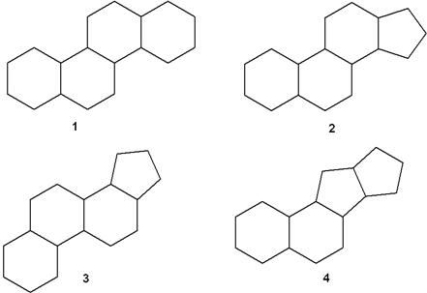
 | a. | 1
 | b. | 2
 | c. | 3
 | d. | 4

ANSWER: | b
POINTS: | 1
QUESTION TYPE: | Multiple Choice
HAS VARIABLES: | False
DATE CREATED: | 3/12/2015 3:24 PM
DATE MODIFIED: | 3/12/2015 3:24 PM

54. Which of the following cycloalkanes has the largest heat of combustion?
 | a. | cyclopropane
 | b. | cyclobutane
 | c. | cyclopentane
 | d. | cyclohexane

ANSWER: | d
POINTS: | 1
QUESTION TYPE: | Multiple Choice
HAS VARIABLES: | False
DATE CREATED: | 3/12/2015 3:24 PM
DATE MODIFIED: | 3/12/2015 3:24 PM

55. Which of the following cycloalkanes has the largest heat of combustion per carbon atom?
 | a. | cyclopropane
 | b. | cyclopentane
 | c. | cyclohexane
 | d. | cycloheptane

ANSWER: | a
POINTS: | 1
QUESTION TYPE: | Multiple Choice
HAS VARIABLES: | False
DATE CREATED: | 3/12/2015 3:24 PM
DATE MODIFIED: | 3/12/2015 3:24 PM

56. Which of the following cycloalkanes has the smallest heat of combustion per carbon atom?
 | a. | cyclopropane
 | b. | cyclopentane
 | c. | cyclohexane
 | d. | cycloheptane

ANSWER: | c
POINTS: | 1
QUESTION TYPE: | Multiple Choice
HAS VARIABLES: | False
DATE CREATED: | 3/12/2015 3:24 PM
DATE MODIFIED: | 3/12/2015 3:24 PM

57. Which of the following structures is different from the other three?
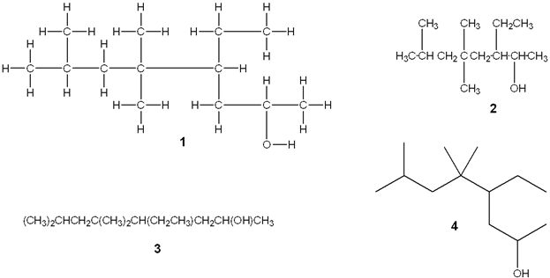
 | a. | 1
 | b. | 2
 | c. | 3
 | d. | 4

ANSWER: | b
POINTS: | 1
QUESTION TYPE: | Multiple Choice
HAS VARIABLES: | False
DATE CREATED: | 3/12/2015 3:24 PM
DATE MODIFIED: | 3/12/2015 3:24 PM

58. Which of the following structures is different from the other three?
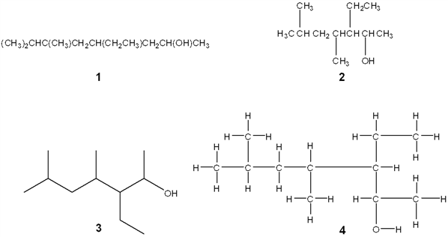
 | a. | 1
 | b. | 2
 | c. | 3
 | d. | 4

ANSWER: | a
POINTS: | 1
QUESTION TYPE: | Multiple Choice
HAS VARIABLES: | False
DATE CREATED: | 3/12/2015 3:24 PM
DATE MODIFIED: | 3/12/2015 3:24 PM

59. Which of the following substituted cyclohexanes has the most negative value of ΔG° for ring flipping from the conformation in which the substituent is axial to the one where it is equatorial?
 | a. | methylcyclohexane
 | b. | chlorocyclohexane
 | c. | isopropylcyclohexane
 | d. | ethynylcyclohexane

ANSWER: | c
POINTS: | 1
QUESTION TYPE: | Multiple Choice
HAS VARIABLES: | False
DATE CREATED: | 3/12/2015 3:24 PM
DATE MODIFIED: | 3/12/2015 3:24 PM

60. Which of the following substituted cyclohexanes has the most negative value of ΔG° for ring flipping from the conformation in which the substituent is axial to the one where it is equatorial?
 | a. | fluorocyclohexane
 | b. | methylcyclohexane
 | c. | ethylcyclohexane
 | d. | tert-butylcyclohexane

ANSWER: | d
POINTS: | 1
QUESTION TYPE: | Multiple Choice
HAS VARIABLES: | False
DATE CREATED: | 3/12/2015 3:24 PM
DATE MODIFIED: | 3/12/2015 3:24 PM

61. The Newman projection of the gauche conformation of 1,2-dichloroethane is shown below.
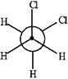
 | a. | True
 | b. | False

ANSWER: | True
POINTS: | 1
QUESTION TYPE: | True / False
HAS VARIABLES: | False
DATE CREATED: | 3/12/2015 3:24 PM
DATE MODIFIED: | 3/10/2017 1:33 AM

62. The most stable conformation of an alkane occurs when carbon−carbon bonds are staggered and bulky groups are anti.
 | a. | True
 | b. | False

ANSWER: | True
POINTS: | 1
QUESTION TYPE: | True / False
HAS VARIABLES: | False
DATE CREATED: | 3/12/2015 3:24 PM
DATE MODIFIED: | 3/12/2015 3:24 PM

63. The following pairs of Newman projections represent the same compound but in differing conformations.
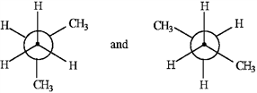
 | a. | True
 | b. | False

ANSWER: | False
POINTS: | 1
QUESTION TYPE: | True / False
HAS VARIABLES: | False
DATE CREATED: | 3/12/2015 3:24 PM
DATE MODIFIED: | 3/10/2017 1:38 AM

64. There are four constitutional isomers for the molecular formula C₆H₁₄.
 | a. | True
 | b. | False

ANSWER: | False
POINTS: | 1
QUESTION TYPE: | True / False
HAS VARIABLES: | False
DATE CREATED: | 3/12/2015 3:24 PM
DATE MODIFIED: | 3/12/2015 3:24 PM

65. The following Newman projection represents 2-methylhexane.
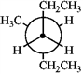
 | a. | True
 | b. | False

ANSWER: | False
POINTS: | 1
QUESTION TYPE: | True / False
HAS VARIABLES: | False
DATE CREATED: | 3/12/2015 3:24 PM
DATE MODIFIED: | 3/10/2017 1:37 AM

66. The following structures represent, from left to right, a cis and a trans isomer.
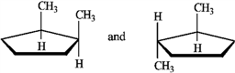
 | a. | True
 | b. | False

ANSWER: | True
POINTS: | 1
QUESTION TYPE: | True / False
HAS VARIABLES: | False
DATE CREATED: | 3/12/2015 3:24 PM
DATE MODIFIED: | 3/10/2017 1:37 AM

67. The following structures represent a pair of constitutional isomers.
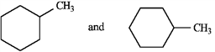
 | a. | True
 | b. | False

ANSWER: | False
POINTS: | 1
QUESTION TYPE: | True / False
HAS VARIABLES: | False
DATE CREATED: | 3/12/2015 3:24 PM
DATE MODIFIED: | 3/10/2017 1:38 AM

68. 3-methylhexylcyclopentane represents a correct IUPAC name.
 | a. | True
 | b. | False

ANSWER: | False
POINTS: | 1
QUESTION TYPE: | True / False
HAS VARIABLES: | False
DATE CREATED: | 3/12/2015 3:24 PM
DATE MODIFIED: | 3/12/2015 3:24 PM

69. In the following structure the positions labeled a and d are equatorial positions.
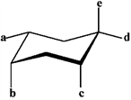
 | a. | True
 | b. | False

ANSWER: | True
POINTS: | 1
QUESTION TYPE: | True / False
HAS VARIABLES: | False
DATE CREATED: | 3/12/2015 3:24 PM
DATE MODIFIED: | 3/13/2017 2:28 AM

70. In the following conversion, the conformations are of equal stability.
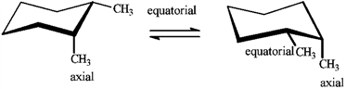
 | a. | True
 | b. | False

ANSWER: | True
POINTS: | 1
QUESTION TYPE: | True / False
HAS VARIABLES: | False
DATE CREATED: | 3/12/2015 3:24 PM
DATE MODIFIED: | 3/10/2017 4:39 AM

71. The correct IUPAC name for the following compound is___________________________.
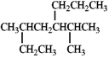
ANSWER: | 3-methyl-5-(1-methylethyl)octane  3-methyl-5-isopropyloctane
POINTS: | 1
QUESTION TYPE: | Completion
HAS VARIABLES: | False
DATE CREATED: | 3/12/2015 3:24 PM
DATE MODIFIED: | 3/13/2017 2:29 AM

72. The tertiary carbon atom in the following structure is indicated by the letter_____.
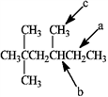
ANSWER: | b  B
POINTS: | 1
QUESTION TYPE: | Completion
HAS VARIABLES: | False
DATE CREATED: | 3/12/2015 3:24 PM
DATE MODIFIED: | 3/13/2017 2:30 AM

Match the Newman projection for the conformation of 2-methylbutane to the indicated position on the potential energy diagram.
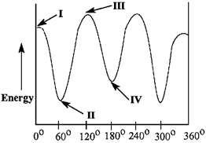
​
A | B | C | D

73. Conformation A is represented by Roman numeral ____.
ANSWER: | II
POINTS: | 1
QUESTION TYPE: | Completion
HAS VARIABLES: | False
PREFACE NAME: | PE Diagram
DATE CREATED: | 3/12/2015 3:24 PM
DATE MODIFIED: | 3/12/2015 3:24 PM

74. Conformation B is represented by Roman numeral ____.
ANSWER: | III
POINTS: | 1
QUESTION TYPE: | Completion
HAS VARIABLES: | False
PREFACE NAME: | PE Diagram
DATE CREATED: | 3/12/2015 3:24 PM
DATE MODIFIED: | 3/12/2015 3:24 PM

75. Conformation C is represented by Roman numeral ____.
ANSWER: | IV
POINTS: | 1
QUESTION TYPE: | Completion
HAS VARIABLES: | False
PREFACE NAME: | PE Diagram
DATE CREATED: | 3/12/2015 3:24 PM
DATE MODIFIED: | 3/12/2015 3:24 PM

76. Conformation D is represented by Roman numeral ____.
ANSWER: | I
POINTS: | 1
QUESTION TYPE: | Completion
HAS VARIABLES: | False
PREFACE NAME: | PE Diagram
DATE CREATED: | 3/12/2015 3:24 PM
DATE MODIFIED: | 3/12/2015 3:24 PM

77. What is the IUPAC name of the following compound?
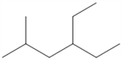
ANSWER: | 4-ethyl-2-methylhexane
POINTS: | 1
QUESTION TYPE: | Subjective Short Answer
HAS VARIABLES: | False
DATE CREATED: | 3/12/2015 3:24 PM
DATE MODIFIED: | 3/12/2015 3:24 PM

78. What is the IUPAC name of the following compound?
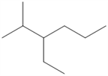
ANSWER: | 3-ethyl-2-methylhexane
POINTS: | 1
QUESTION TYPE: | Subjective Short Answer
HAS VARIABLES: | False
DATE CREATED: | 3/12/2015 3:24 PM
DATE MODIFIED: | 3/12/2015 3:24 PM

79. What is the IUPAC name of the following compound?
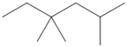
ANSWER: | 2,4,4-trimethylhexane
POINTS: | 1
QUESTION TYPE: | Subjective Short Answer
HAS VARIABLES: | False
DATE CREATED: | 3/12/2015 3:24 PM
DATE MODIFIED: | 3/12/2015 3:24 PM

80. What is the IUPAC name of the following compound?
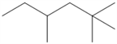
ANSWER: | 2,2,4-trimethylhexane
POINTS: | 1
QUESTION TYPE: | Subjective Short Answer
HAS VARIABLES: | False
DATE CREATED: | 3/12/2015 3:24 PM
DATE MODIFIED: | 3/12/2015 3:24 PM

81. What is the IUPAC name of the following compound?
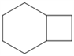
ANSWER: | bicyclo[4.2.0]octane
POINTS: | 1
QUESTION TYPE: | Subjective Short Answer
HAS VARIABLES: | False
DATE CREATED: | 3/12/2015 3:24 PM
DATE MODIFIED: | 3/12/2015 3:24 PM

82. What is the IUPAC name of the following compound?
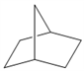
ANSWER: | bicyclo[2.2.1]heptane
POINTS: | 1
QUESTION TYPE: | Subjective Short Answer
HAS VARIABLES: | False
DATE CREATED: | 3/12/2015 3:24 PM
DATE MODIFIED: | 3/12/2015 3:24 PM

83. What is the IUPAC name of the following compound?
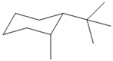
ANSWER: | cis-1-tert-butyl-2-methylcyclohexane  [ignoring absolute stereochemistry in Chap 2]
POINTS: | 1
QUESTION TYPE: | Subjective Short Answer
HAS VARIABLES: | False
DATE CREATED: | 3/12/2015 3:24 PM
DATE MODIFIED: | 3/12/2015 3:24 PM

84. What is the IUPAC name of the following compound?
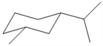
ANSWER: | cis-1-isopropyl-3-methylcyclohexane  [ignoring absolute stereochemistry in Chap 2]
POINTS: | 1
QUESTION TYPE: | Subjective Short Answer
HAS VARIABLES: | False
DATE CREATED: | 3/12/2015 3:24 PM
DATE MODIFIED: | 3/12/2015 3:24 PM

85. How many hydrogen atoms are there in decane?
ANSWER: | 22
POINTS: | 1
QUESTION TYPE: | Subjective Short Answer
HAS VARIABLES: | False
DATE CREATED: | 3/12/2015 3:24 PM
DATE MODIFIED: | 3/12/2015 3:24 PM

86. How many hydrogen atoms are there in octane?
ANSWER: | 18
POINTS: | 1
QUESTION TYPE: | Subjective Short Answer
HAS VARIABLES: | False
DATE CREATED: | 3/12/2015 3:24 PM
DATE MODIFIED: | 3/12/2015 3:24 PM

87. What are the common and IUPAC names of the following compound?
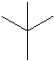
ANSWER: | common: neopentane  IUPAC: 2,2-dimethylpropane
POINTS: | 1
QUESTION TYPE: | Subjective Short Answer
HAS VARIABLES: | False
DATE CREATED: | 3/12/2015 3:24 PM
DATE MODIFIED: | 3/12/2015 3:24 PM

88. What are the common and IUPAC names of the following compound?
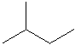
ANSWER: | common: isopentane  IUPAC: 2-dimethylbutane
POINTS: | 1
QUESTION TYPE: | Subjective Short Answer
HAS VARIABLES: | False
DATE CREATED: | 3/12/2015 3:24 PM
DATE MODIFIED: | 3/12/2015 3:24 PM

89. What is the IUPAC name of the following compound?
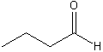
ANSWER: | butanal
POINTS: | 1
QUESTION TYPE: | Subjective Short Answer
HAS VARIABLES: | False
DATE CREATED: | 3/12/2015 3:24 PM
DATE MODIFIED: | 3/12/2015 3:24 PM

90. What is the IUPAC name of the following compound?
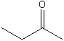
ANSWER: | butanone
POINTS: | 1
QUESTION TYPE: | Subjective Short Answer
HAS VARIABLES: | False
DATE CREATED: | 3/12/2015 3:24 PM
DATE MODIFIED: | 3/12/2015 3:24 PM

91. Provide a line-bond structure of hexanoic acid.
ANSWER:
POINTS: | 1
QUESTION TYPE: | Subjective Short Answer
HAS VARIABLES: | False
DATE CREATED: | 3/12/2015 3:24 PM
DATE MODIFIED: | 3/12/2015 3:24 PM

92. Provide a line-bond structure of pentanal.
ANSWER:
POINTS: | 1
QUESTION TYPE: | Subjective Short Answer
HAS VARIABLES: | False
DATE CREATED: | 3/12/2015 3:24 PM
DATE MODIFIED: | 3/12/2015 3:24 PM

93. Provide a Newman projection of the most stable conformation of 2-methylpentane, (CH₃)₂CHCH₂CH₂CH₃, looking along the C2-C3 bond
ANSWER:
POINTS: | 1
QUESTION TYPE: | Subjective Short Answer
HAS VARIABLES: | False
DATE CREATED: | 3/12/2015 3:24 PM
DATE MODIFIED: | 3/10/2017 5:50 AM

94. Provide a Newman projection of the most stable conformation of 3-methylpentane, CH₃CH₂CH(CH₃)CH₂CH₃ looking along the C2-C3 bond.
ANSWER:
POINTS: | 1
QUESTION TYPE: | Subjective Short Answer
HAS VARIABLES: | False
DATE CREATED: | 3/12/2015 3:24 PM
DATE MODIFIED: | 3/12/2015 3:24 PM

95. Provide a neatly drawn plot of energy versus dihedral angle for rotation around the C2-C3 bond of butane.
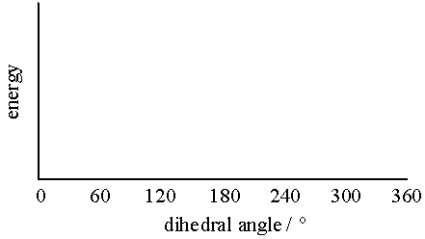
ANSWER:
POINTS: | 1
QUESTION TYPE: | Subjective Short Answer
HAS VARIABLES: | False
DATE CREATED: | 3/12/2015 3:24 PM
DATE MODIFIED: | 3/12/2015 3:24 PM

96. Provide a neatly drawn plot of energy versus dihedral angle for rotation around the C-C bond of ethane.
ANSWER:
POINTS: | 1
QUESTION TYPE: | Subjective Short Answer
HAS VARIABLES: | False
DATE CREATED: | 3/12/2015 3:24 PM
DATE MODIFIED: | 3/12/2015 3:24 PM

97. Identify the constitutional isomer with the molecular formula C₇H₁₆.
​
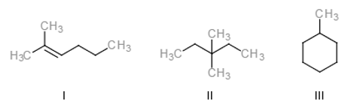
 | a. | Only I
 | b. | Only I and II
 | c. | Only II
 | d. | I, II, and III

ANSWER: | c
POINTS: | 1
QUESTION TYPE: | Multiple Choice
HAS VARIABLES: | False
DATE CREATED: | 4/11/2017 7:38 AM
DATE MODIFIED: | 4/13/2017 1:02 AM

98. The molecular formulas of neopentane and isobutane are _____ and _____, respectively.
 | a. | C₅H₁₂; C₄H₈
 | b. | C₅H₁₀; C₄H₁₀
 | c. | C₅H₁₂; C₄H₁₁
 | d. | C₅H₁₂; C₄H₁₀

ANSWER: | d
POINTS: | 1
QUESTION TYPE: | Multiple Choice
HAS VARIABLES: | False
DATE CREATED: | 4/11/2017 7:54 AM
DATE MODIFIED: | 4/11/2017 7:55 AM

99. The total numbers of 2⁰ and 3⁰ carbon atoms in the following structure are _____ and _____, respectively.
​
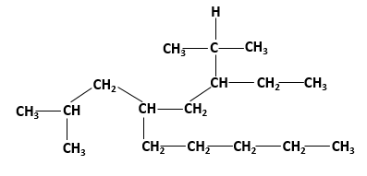
 | a. | 3; 7
 | b. | 7; 4
 | c. | 4; 6
 | d. | 6; 4

ANSWER: | b
POINTS: | 1
QUESTION TYPE: | Multiple Choice
HAS VARIABLES: | False
DATE CREATED: | 4/11/2017 7:57 AM
DATE MODIFIED: | 4/11/2017 8:00 AM

100. What is “X” in the following reaction?
​
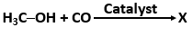
a.
b.
c.
d.

ANSWER: | a
POINTS: | 1
QUESTION TYPE: | Multiple Choice
HAS VARIABLES: | False
DATE CREATED: | 4/11/2017 8:01 AM
DATE MODIFIED: | 4/11/2017 8:09 AM

101. What is “X” in the following reaction?
​
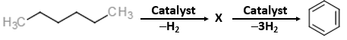
a.
b.
c.
d.

ANSWER: | a
POINTS: | 1
QUESTION TYPE: | Multiple Choice
HAS VARIABLES: | False
DATE CREATED: | 4/11/2017 8:04 AM
DATE MODIFIED: | 4/11/2017 8:09 AM

102. What is “X” in the following reaction?
​
a.
b.
c.
d.

ANSWER: | d
POINTS: | 1
QUESTION TYPE: | Multiple Choice
HAS VARIABLES: | False
DATE CREATED: | 4/11/2017 8:10 AM
DATE MODIFIED: | 4/19/2017 12:56 AM

Match the structures with their IUPAC names.
a. |  | b.
c.

QUESTION TYPE: | Matching
HAS VARIABLES: | False
DATE CREATED: | 4/11/2017 8:15 AM
DATE MODIFIED: | 4/11/2017 8:26 AM

103. 3-ethyl-2-methylhexane
ANSWER: | a
POINTS: | 1

104. 4-ethyl-2,2-dimethylhexane
ANSWER: | b
POINTS: | 1

105. 4-ethyl-2-methylhexane
ANSWER: | c
POINTS: | 1

