End of Chapter Material

Chapter 2

**ANSWER KEY – CHAPTER 2 END OF CHAPTER MATERIAL**

CRITICAL THINKING

CT-1 A scientist has two buckets—one holds 4 gallons and the other holds 5 gallons—as well as an unlimited water supply.

By using nothing but the buckets and water, how can you accurately measure 3 gallons of water?

*Solution:*

*Fill the 4-gallon bucket*

*Dump the 4-gallon bucket into the 5-gallon bucket*

*Fill the 4-gallon bucket*

*Top off the 5-gallon bucket (i.e., dump 1 gallon from the 4-gallon bucket into the 5-gallon bucket)*

*Done: the 4-gallon bucket has 3 gallons remaining (accurately measured)*

CT-2 Three people check into a hotel. They pay $30 to the manager and go to their room. The manager suddenly remembers that the room rate is $25 and gives $5 to the bellboy to return to the people. On the way to the room, the bellboy reasons that $5 would be difficult to share among three people so he pockets $2 and gives $1 to each person. Now each person paid $10 and got back $1. So they paid $9 each, totaling $27. The bellboy has $2, totaling $29. Where is the missing $1?"

*Solution:*

*Be careful of what you are adding together. Originally, they paid $30, they each received back $1; thus they now have only paid $27. Of this $27, $25 went to the manager for the room and $2 went to the bellboy.*

REVIEW QUESTIONS

2-RQ #1. Describe occupational fraud and abuse.

Answer: Occupational fraud and abuse is defined as “the use of one’s occupation for personal enrichment through the deliberate misuse or misapplication of the employing organization’s resources or assets.” Occupational fraud and abuse involves a wide variety of conduct by executives, employees, managers, and principals of organizations, ranging from sophisticated investment swindles to

petty theft. Common violations include asset misappropriation, fraudulent statements, corruption, pilferage, petty theft, false overtime, using company property for personal benefit, fictitious payroll, and sick time abuses.

2-RQ #2. Compare and contrast Cressey’s and Albrecht’s theories of crime causation.

Answer: Although Cressey focused on embezzlement and Albrecht focused on occupational frauds, their elements were very similar. According to Albrecht, three elements must be present for a fraud to be committed: a situational pressure, a perceived opportunity to commit and conceal the dishonest act, and some way to rationalize (justify) the act as either being inconsistent with one’s personal level of integrity or acceptable under the circumstances. According to Cressey, the three elements are perceived pressure or a nonshareable financial pressure, a way to secretly resolve the dishonest act or the lack of deterrence by management via a perceived opportunity, and finally some way to rationalize the act, because the perpetrator does not see himself or herself as a criminal.

2-RQ #3. Identify from Cressey’s research the six situational categories that cause non-shareable problems.

Answer: Cressey found that the nonshareable problems encountered by the people

he interviewed arose from situations that could be divided into six basic categories:

• violation of ascribed obligations

• problems resulting from personal failure

• business reversals

• physical isolation

• status gaining

• employer-employee relations

2-RQ #4. Discuss the essence of organizational crime.

Answer: Organizational crimes occur when entities—companies, corporations, not-for- profits, nonprofits, and government agencies—otherwise legitimate and law-abiding organizations, are involved in a criminal offense. In addition, individual organizations can be trust violators when the illegal activities of the organization are reviewed and approved by persons with high standing in an organization such as board members, executives, and managers. Federal law allows organizations to be prosecuted in a manner similar to individuals. For example, although the Arthur Andersen conviction was later overturned by the U.S. Supreme Court, the organization was convicted of obstruction of justice, a felony offense that prevented them from auditing public companies. Corporate violations may include administrative breaches, such as noncompliance with agency, regulatory, and court requirements; environmental infringements; fraud and financial crimes, such as bribery and illegal kickbacks; labor abuses; manufacturing infractions related to public safety and health; and unfair trade practices.

2-RQ #5. Give examples of behavioral indications of fraud.

Answer: Behavioral symptoms of fraud can include such behavior as:

• Can’t look people in the eye

• Embarrassment with friends, family

• Irritable and suspicious

• Defensive

• Argumentative

• Unusually belligerent in stating opinions

• Needs to see a counselor, psychiatrist, etc.

• Complains of being unable to sleep

• Drinks too much

• Using illegal, illicit drugs

• Can’t relax

2-RQ #6. Explain the relationship between an employee’s position and the level of theft (according to Hollinger and Clark’s research).

Answer: Hollinger and Clark were able to confirm a direct relationship between an

employee’s position and the level of the theft, with thefts being highest in jobs with greater access to the things of value in the organization. Although they found obvious connections between opportunity and theft (for example, retail cashiers with daily access to cash had the highest incidence), the researchers believed opportunity to be “ . . . only a secondary factor that constrains the manner in which the deviance is manifested.” Their research indicated that job satisfaction was the primary motivator of employee theft; the employee’s position only affects the method and amount of the theft after the decision to steal has already been made.

2-RQ-7 Analyze how the fraud triangle would be adjusted for predator fraudsters.

Answer: While pressure and rationalization may play some role with choices made by repeat offenders, arrogance and the criminal mindset are likely to influence the actions of the predator. The main focus of the predator from the original fraud triangle is opportunity.

2-RQ-8 Analyze how the fraud triangle would be adjusted for collusive fraud teams.

Answer: The three factors in the fraud triangle are drawn from an individual perspective that focuses on individual perpetrators (solo offenders). Each colluding actor is subject to different incentives, pressures, rationalizations, and opportunities during the inception and perpetration of collusive fraud. It’s likely in a collusive environment that some participants face coercion while each willing participant likely has a unique incentive or pressure. With a collusive team, opportunity is greatly expanded; capability is likely enhanced and oversight control might be weakened, bypassed or removed. Rationalization is likely unique but group membership (it’s ok because others are doing it) likely becomes easier.

2-RQ-9 Using the M.I.C.E. acronym, examine whether ideology, coercion and ego / entitlement constitute frauds, given that the monetary benefit of the fraud to the perpetrator might be relatively small or non-existent.

Answer: According to the 1996 Report to the Nation on Occupational Fraud and Abuse, “The key is that the activity (1) is clandestine, (2) violates the employee’s fiduciary duties to the organization, (3) is committed for the purpose of direct or indirect financial benefit to the employee, and

(4) costs the employing organization assets, revenues, or reserves.” The cost to the organization does not necessarily need to translate into benefits directly accruable to the perpetrator. As such, motivations associated with ideology, coercion and ego / entitlement are not preclude from meeting the definition of fraud.

2-RQ-10 Explain the benefits of the triangle of fraud action in comparison to the fraud triangle in courtroom testimonial situations.

Answer: The triangle of fraud action provides direct evidence of the fraud act and the perpetrators roles in the fraud. In contrast, the fraud triangle helps us understand why perpetrators might choose to commit fraud.

MULTIPLE CHOICE QUESTIONS

2-MC-1. Select the statement that best describes organizational versus organized crime:

A. Organizational and organized crime are essentially the same, both center on crimes committed by organizations.

B. Some of the crimes typically associated with organized crime include money laundering, mail and wire fraud, conspiracy and racketeering.

C. Organized crime occurs when otherwise legitimate and law-abiding organizations are involved in a criminal offense.

D. Some of the crimes typically associated with organizational crime include money laundering, mail and wire fraud, conspiracy and racketeering.

Answer: B. Some of the crimes typically associated with organized crime include money laundering, mail and wire fraud, conspiracy and racketeering. Organizational crimes occur when entities, companies, corporations, not-for-profits, nonprofits, and government agencies, otherwise legitimate and law-abiding organizations, are involved in a criminal offense. Corporate violations may include administrative breaches, such as noncompliance with agency, regulatory, and court requirements; environmental infringements; fraud and financial crimes, such as financial reporting fraud, bribery and illegal kickbacks; labor abuses; manufacturing infractions related to public safety and health; and unfair trade practices.

2-MC-2. Which of the following is true with regard to Cressey’s theory of crime causation?

A. For a fraud to occur, only one of the fraud triangle attributes (perceived pressure, perceived opportunity or rationalization) needs to be present.

B. Opportunity includes both the opportunity to complete the fraud as well as conceal it without getting caught.

C. Financial pressure that is sharable will never result in a fraud.

D. Rationalization is the least important attribute of the fraud triangle.

Answer: B. Opportunity includes both the opportunity to complete and conceal the fraud – both without getting caught.

2-MC-3. Identify which of the following is not considered a non-shareable problems from Cressey’s research?

A. Business reversal such as bankruptcy.

B. Losses due to gambling.

C. Justification of the fraud act by blaming the employer for poor work conditions.

D. Personal problem such as an uninsured medical claim.

Answer: C. This excuse, “justification of the fraud act by blaming the employer for poor work conditions,” is more consistent with the notion of a rationalization.

2-MC-4. In the Albrecht Fraud Scale, which of the following is true?

A. The fraud scale adds the characteristic of capability to the fraud triangle.

B. The fraud scale adds the characteristic of integrity to the fraud triangle.

C. The fraud scale adds the characteristic of rationalization to the fraud triangle.

D. The fraud scale substitutes integrity in place of rationalization.

Answer: D. Like the fraud triangle, the fraud scale has three elements, two of which (pressure and opportunity) overlap. The fraud scale substitutes integrity in place of rationalization.

2-MC-5. Which of the following is not a behavioral indicator of fraud?

A. Buying new luxury cars or wearing expensive jewelry.

B. Acting irritable, defensive or in a belligerent manner.

C. Not taking vacations of more than two or three days.

D. Failing to retain adequate financial records.

Answer: D. Failing to retain adequate financial records might be evidence of a concealment effort, but is less behavioral in nature.

2-MC-6. Which of the following best describes the relationship between an employee’s position and theft (according to Hollinger and Clark’s research)?

A. The more expensive thefts are observed in jobs with greater access to the assets of value in the organization.

B. The higher the level of employee in an organization, the less likely that employee is to steal due to higher levels of compensation and job satisfaction.

C. Employees with less tenure with an organization are less knowledgeable about internal controls and are therefore more afraid to steal.

D. Hollinger and Clark’s research finding suggest that income is a strong predictor of employee theft.

Answer: A. The more expensive thefts are observed in jobs with greater access to the assets of value in the organization.

2-MC-7. In terms of the definition of occupational fraud and abuse, who is an employee?

A. Any person who receives regular and periodic compensation from an organization for his or her labor.

B. Only rank and file workers.

C. Any trust violator.

D. Respectable business and professional individuals.

Answer: A. This is the definition of an employee in the context of occupational fraud and abuse.

2-MC-8. The difference between fraud and errors is:

A. the materiality of the value involved.

B. intent of those involved.

C. whether it affects owners’ equity or not.

D. All of the choices are correct.

Answer: B. In the case of fraud the intent is deception, whereas in an error, there is no intent.

2-MC-9. One of the most important contributions of criminology to the study of fraud is:

A. the M.I.C.E. concept.

B. the fraud triangle.

C. the relationship of punishment to remediation.

D. none of the above.

Answer: B. The fraud triangle is considered one of the most important contributions of criminology to the study of fraud because it describes the three underlying causes/pressures on an individual that, when present, could lead that individual to commit fraud.

2-MC-10. Financial statement fraud is often attributed to pressures. These pressures include all of the following except:

A. investment losses by managers.

B. meeting analysts’ expectations.

C. deadlines, and cutoffs.

D. qualifying for bonuses.

Answer: A. In general, investment losses are a personal issue not considered a pressure attributed to financial reporting fraud.

2-MC-11. Which two adjustments are made to the fraud triangle to accommodate predators?

A. The fraud triangle is not meant to differentiate between accidental and predator fraudsters.

B. Criminal mindset and arrogance substitute for pressure and rationalization.

C. Predators have less pressure because they are more likely to be involved in international money laundering and setting up shell companies, particularly in foreign countries.

D. Criminal mindset and opportunity substitute for pressure and rationalization.

Answer: B. The pressure and rationalization legs of the fraud triangle are replaced with criminal mindset and arrogance in the case of a predator fraudster.

2-MC-12. One major difference between fraud and a mistake is:

1. Concealment
2. Cover-up
3. The act
4. Conversion (benefit to the perpetrator)

Answer: D. A mistake becomes a fraud when the benefits of the error/theft are converted to the perpetrator for personal benefits.

2-MC-13. One way of demonstrating that an act was fraud and not a mistake is by:

A. Demonstrating that the employee concealed the act.

B. Showing that there were multiple incidents of the same act.

C. The destruction of evidentiary documents that describe the act.

D. All of the above.

Answer: B. Proving repeat offenses can be a method of demonstrating an act of fraud over a mistake, because a mistake should be a one-time error, where as a fraudulent act could have several incidences.

2-MC-14. Large fraud perpetrators are more likely to use the money for all of the following except:

A. to purchase new homes.

B. to pay for expensive vacations.

C. to support extramarital affairs.

D. to pay taxes.

Answer: D. In general, if the money is stolen, the perpetrator is not going to use those funds to pay taxes, both because they do not want to and because it puts them at a higher risk of being detected. Instead they attempt to conceal their money from detection to avoid taxation.

FRAUD CASEBOOK

Sources:

Katz, David M. and Julia Homer, “WorldCom Whistle-blower Cynthia cooper, CFO Magazine, February 1, 2008;

Pulliam Susan and Deborah Solomon, “How Three Unlikely Sleuths Exposed Fraud at WorldCom,” The Wall Street Journal, October 30, 2002;

Cooper, Cynthia, “Extraordinary Circumstances: The Journey of a Corporate Whistleblower,” Wiley 2008.

Summary and Solutions to Discussion Questions

CYTHINA COOPER: FROM WORLDCOM INTERNAL AUDIT MANAGER TO TIME “PERSON OF THE YEAR”

Cynthia Cooper’s odyssey began when she decided to investigate anomalies in WorldCom’s accounting entries. At the time, she was WorldCom’s vice president of internal audit. By the end of June 2002, Cooper and her internal audit team consisting primarily of Gene Morse and Glyn Smith had “blown the whistle” on one of the largest corporate frauds in U.S. history - $11 billion.

Cooper says that she first suspected that something might be wrong at WorldCom when her feelings changed from curiosity to discomfort to suspicion based on some of the accounting entries her team and she had identified. She also noted odd reactions from some of WorldCom’s finance executives. For example, the CFO, Scott Sullivan, requested that she delay an audit of capital-expenditures. Later, Cooper received an e-mail from the controller, David Meyers, suggesting that she was wasting her time auditing fixed asset transactions.

According to Cooper, nobody wants to believe that the leadership of a Fortune 500 company is perpetrating a multi-billion dollar fraud. When Cooper showed her evidence to the Company’s external audit partner, he wasn't initially concerned. In fact, the audit committee gave CFO Sullivan a weekend to write a white paper to support WorldCom’s accounting treatment. In a speech in January 2004, Cooper noted that her suspicions grew and that she felt somewhat fearful of physical harm. As a result, her team began working at night and behind closed doors because they didn't want to be detected. Internal audit IT specialist Gene Morse was running so many queries of the accounting system that it was starting to crash. When finally confronted, David Meyers, Controller at the time, confessed – According to Cooper, he felt better than he had in years.

WorldCom became one the dominant players in the telecommunications industry through acquisitions. Between 1991 and 1997, WorldCom spent almost $60 billion in the acquisition of as many as 65 companies, accumulating over $40 billion in debt in the process. Acquisitions of MFS Communications and MCI were particularly important. Through MFS Communications,

WorldCom obtained UUNet, a major supplier of Internet services to business. With MCI Communications, WorldCom was able to tap the residential phone market. By 1997, WorldCom's stock had risen to over $60 a share and the company and Bernie Ebbers, Chief Executive Officer, became darlings of Wall Street. Ebbers was a self-made man; a one-time high school coach, club bouncer and milkman, his entrepreneurial spirit and propensity to take risks, propelled WorldCom to its height of success.

Then in 2000, for anti-trust reasons, the U.S. government refused to permit WorldCom to acquire Sprint, another successful giant in the telecom industry. Acquisitions had been the fuel and mainstay of WorldCom's revenue and profits growth. Unable to acquire growth, WorldCom foresaw the possibility of disappointing Wall Street. Rather than reorganize, develop a new strategy or “come clean,” WorldCom, Bernie Ebbers, Scott Sullivan (CFO) and others perpetrated a fraud estimated to be worth more than $11 billion.

Behind the story of WorldCom, are the ethics, dedication and courage of three internal auditors: Cynthia Cooper, Gene Morse and Glyn Smith. Based on some initial concerns, a confrontation with Scott Sullivan, a curious email and an SEC inquiry, in March 2002, Cooper decided that the internal audit group would start looking at the reliability and integrity of the WorldCom’s financial information.

During their preliminary efforts, the team ran into public disclosure that $2 billion had been spent on capital expenditures during the first three quarters of 2001, despite no documented approvals. Additional work suggested a hypothesis: the mysterious $2 billion might represent operating costs recorded as fixed assets. Cooper and Glyn Smith asked Sanjeev Sethi, a director of financial planning, about the curious accounting; Mr. Sethi described the capitalized asset as "prepaid capacity," a term Cooper had never heard. In reality, by 2000, WorldCom had started to rely on aggressive accounting to conceal deteriorating operations. The expenditures were not “prepaid capacity” but line lease costs, fees paid to “rent” a portion of other companies' telephone networks. Lease line costs were removed from operating expense accounts and buried in the balance sheet as fixed assets. The effect was to improve profits and present a more healthy financial condition for WorldCom.

During May, Gene Morse made another discovery: $500 million in undocumented computer expenses. These expenses had also been recorded as fixed assets.

Capitalizing expenditures with no future value as assets is a clear violation of generally accepted accounting principles. Yet, according to the SEC complaint, it occurred for at least five quarters. By the first week of June, Morse, using his information technology skills, had identified a total of $2 billion in questionable accounting entries. Concerned that the company might attempt to destroy his electronic evidence, Morse used his own money to purchase a CD burner and copy the incriminating files to CD-rom.

On June 17, Cynthia Cooper and Glyn Smith began a series of informal confrontations. The pair started with Betty Vinson, director of management reporting. Vinson admitted to making the entries but confessed that she did not have any support for them. Next they approach Buddy Yates, Director of Accounting, who plead ignorance and sent them to David Meyers.

Myers, WorldCom’s controller, tells all: he admits that he knew the accounting treatment was wrong, electing to end the deception. Cynthia Cooper also asked Meyers if he had any authoritative accounting guidance to support WorldCom’s accounting treatment of line lease costs. Myers indicated that the entries should not have been made, but that once it had started, it was virtually impossible to stop.

On June 20, Cynthia Cooper and Glyn Smith flew to Washington, D.C. to brief WorldCom's audit committee. At the meeting, Farrell Malone, engagement partner for WorldCom’s newly appointed auditor KPMG, described how WorldCom appeared to have capitalized line costs as fixed assets and told the audit committee that he didn’t believe that the accounting treatment complied with generally accepted accounting principles.

The audit committee allowed Scott Sullivan, CFO, the weekend to defend his company’s accounting choices. Sullivan constructed a white paper that argued that the accounting treatment was proper, matching the line lease excess capacity costs to future revenues. In reality, while generally accepted accounting principles does have a matching principle, Sullivan’s arguments did not comply with that principle nor did his arguments comply with the basic definition of an asset: a resource controlled by the company with future value.

On June 24, the audit committee told Mr. Sullivan and Mr. Myers they would be terminated if they didn't resign. Scott Sullivan, CFO, refused and was fired. David Myers, controller, resigned. The next evening, WorldCom announced that it had inflated profits by $3.8 billion over the previous five quarters. On June 26, the SEC filed a civil fraud suit against WorldCom, and trading of WorldCom's stock was halted. Ultimately the company was delisted by the Nasdaq Stock Market and in July 2002, WorldCom filed for bankruptcy protection. By the time investigators got to the bottom of the fraud, WorldCom admitted to a $9 billion adjustment for the period from 1999 through the first quarter of 2002.

Cooper says that exposing WorldCom's fraud was "the most difficult thing I've ever been through in my life.” “Sometimes," she adds, "doing the right thing has a cost, and that cost can be severe.” After leaving WorldCom, Cooper formed Cynthia Cooper Consulting and started speaking to corporations, associations, and universities about ethics and leadership. She continues providing advice on corporate ethics to corporations and business schools throughout North America.

In the aftermath, the 63 year-old Bernie Ebbers was sentenced to 25 years in prison. In addition, Ebbers had agreed to forfeit the bulk of his assets including a $45 million Mississippi mansion, keeping a modest home for his wife and $50,000. Scott Sullivan, CFO, received a five-year sentence. Controller David Meyers and Director of Accounting Buddy Yates were both sentenced to a one-year prison term. Betty Vinson, accounting department manager, was sentenced to 5 months in prison and 5 months home detention. Cynthia Cooper writes: Most of the people who participated in the WorldCom fraud were ordinary, middle-class Americans.

They were mothers and fathers who went to work to support their families. They had no prior criminal records and never imagined they would be confronted with such life-altering choices. Cynthia Cooper was named one of Time Magazine’s 2002 persons of the year for her heroic role as WorldCom whistle blower.

Short Answer Questions

1. What was Cynthia Cooper’s position at WorldCom?

2. Approximately how much value was lost as a result of the WorldCom collapse?

3. Which WorldCom employee initially confessed to the fraud and what was his position?

4. List Cynthia Cooper’s two colleagues who assisted her with uncovering the WorldCom fraud.

5. Was there ever a concern over the discovery of the investigation and possible destruction of evidence?

6. Did complicated computer programming and analysis play a role in the investigation?

Answers to Short Answer Questions

1. Vice President of Internal Audit

2. Ultimately, $11 billion

3. David Meyers, Controller

4. Gene Morse and Glyn Smith

5. Yes

6. Yes

Discussion Questions

1. From an ethical perspective, did Cynthia Cooper have to report this fraud? Why or why not?

2. What ethical issues, conflicts of interest, and non-compliance with corporate policies and procedures might Cynthia Cooper have faced in the context of her investigation?

3. What alternative courses of action, if any, might you have suggested for Cynthia Cooper and her colleagues given the framework of appropriate ethical conduct?

**Answers to Discussion Questions** can be found within the Fraud Casebook Summary.

BRIEF CASES

1. Assume the following facts and circumstance are grounded in evidence:

a. A retired couple has a life-time of community involvement and service.

b. Evidence supports the retired couple becoming involved in a money-laundering scheme late in life through a small business owned and operated by them.

c. Evidence suggests that the benefit (conversion) to the retired couple is nominal, and most estimates suggest monetary benefits of approximately zero.

d. Evidence eliminates all employees, except the owners, of involvement in the money laundering activity.

e. The retired couple has a son who has a history of drug use and minor drug trafficking.

f. The means by which the money is passing through the small business is connected by evidence to the son.

Case Discussion: Which fraud model, the fraud triangle, the fraud scale or the acronym M.I.C.E. offers the best possible explanation for the actions of the couple? Why?

Solution:

The actions of the retired couple are most consistent with the acronym M.I.C.E., particularly ideology. The retired couple does not appear to being gaining any benefit from their actions; thus money does not provide an explanation. None of the evidence presented in the case suggest ego or entitlement. While there is no evidence of coercion, one might argue that additional evidence should be solicited to eliminate coercion by the son as a motivation, but as presented, there is no evidence of coercion.

2. Assume the following facts and circumstance are grounded in evidence:

a. An information technology employee has control over of aspects of business operations of a small business, including financial and non-financial information.

b. The small business is contracting for services that are not needed nor performed by a service provider.

c. Evidence suggest that the benefit (conversion) is indirectly tied to the IT employee and the owner of the service provider who appear to be splitting the proceeds proportionally.

d. Evidence eliminates all other employees except the IT employee.

e. Evidence suggests that both the IT employee and owner pf the service provider as “shady characters,” both with juvenile offense records, speeding tickets and police reports to domestic issues in the local papers (no convictions on record).

Case Discussion: Which fraud model, the fraud triangle, the fraud scale or the acronym M.I.C.E. offers the best possible explanation for the actions of this collusive fraud team: the IT employee and owner of the service provider? Why?

Solution:

Collusive frauds are more difficult in terms of motivation and aligning the acts of the perpetrators with traditional fraud models. However, in this case, the case facts seems to suggest a garden variety embezzlement scheme where one party is inside of the organization while the accomplice is outside the organization. While the specifics suggest that the fraud triangle or the fraud scale might be relevant, personal integrity appears to be an issue; thus, the facts align best with the fraud scale model.

MAJOR CASE INVESTIGATION

The following is the “inventory” of items received to continue the examination at Johnson Real Estate. In this chapter, the goal is to focus on the missing deposits. In a future chapter, work will continue on the unusual disbursements.

* Fire Marshall’s Report
* Johnson Real Estate, First Choice Bank account, January, 20X9 – January 20X0 Bank Statement
* Memorandum to Case File: Broker Commissions

These items will be provided by the course instructor.

Assignment:

Continuing to focus on evidence associated with the act, concealment and conversion, use the evidentiary material to continue the investigation. Your primary assignment is to confirm predication with regard to the possible fraud act of missing deposits.

Solution:

1. The Fire Marshall’s report is inconclusive. In provides no probative evidence regarding concealment.

2. See the separate Excel document. The missing deposits are confirmed. Preliminarily, missing deposits total -42,045.00. The professor should note that the last “missing deposit” (-11,115.00) is not a round number amount and looks different than the prior amounts. In a later chapter, students will receive evidence that this is actually a bank deposit error. A deposit in the amount of $12,350 was recorded by the bank at $1,235. When revealed, the provides students with a cautionary tale to (a) keep searching for evidence (b) do not jump to conclusions while the examination is on-going, and (c) always leave room to update an examination for situations if / when new evidence arises.



IDEA Exercises

Assignment 2

Case IDEA Background: See Chapter 1.

Question. Do any accounting or payroll personnel or related parties appear on the contractor payroll?

1. Click on the “Analysis” tab
2. Click on “summarization” in the “categorize” box
3. Set the “Fields to Summarize” to “LastName”
4. Set “Then by” to “FirstName”
5. Click on (i.e., check) “Hours” and “Gross” boxes in the “Numeric fields to total”
6. Click “OK”

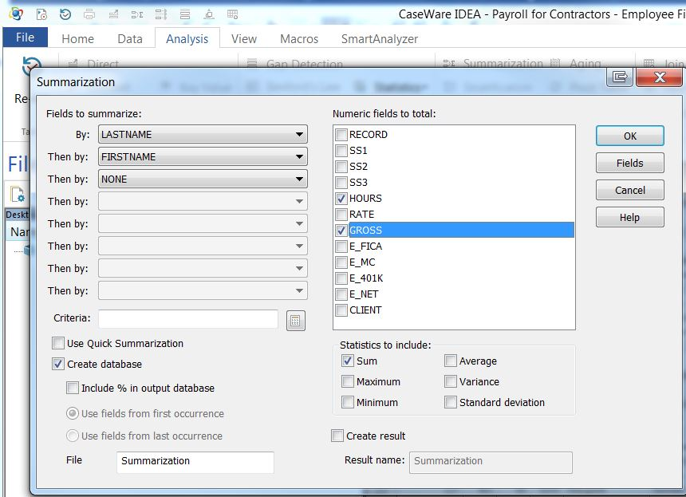

Export the Results to Excel

1. Choose the “File” tab (red box)
2. Select “Export” (blue oval)
3. Select “Microsoft Excel 2007-2010” and set up the location to save using the “File Name” browse feature to set up a location and name the file
4. Click “Save”
5. Click “OK”

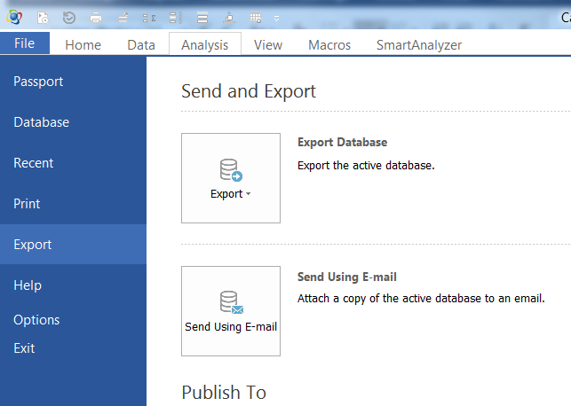

Student Task: Students should (a) present a listing of any accounting or payroll personnel who are being inappropriately paid through the contractor (attorney) payroll system and/or any related parties who might need additional examination scrutiny and (b) discuss the findings and recommend investigative next steps.

The results (solution):



Recall that the case background indicates that administration personnel should not be paid through the payroll system for contract labor. Yet, the payroll manager, Christine Alexander, and general accountant, Carrie Rutten, both have payroll dollars. Alexander is the 3rd highest paid “attorney”, though she is not an attorney. These should be considered red flags and investigated. Helene Earls is a related party and is the 2nd highest paid attorney. Her payroll should be carefully scrutinized, though she is an attorney engaged to complete work for clients.



Tableau Exercises

Assignment 2

Case Tableau Background: See Chapter 1.

The forensic accounting analysis determined that two accounting personnel were identified as inappropriately receiving disbursements through the contract attorney payroll. Administrative personnel paid through the contract attorney payroll were identified as “1” in the variable column “AEmp”.

Question. Which clients, if any, were invoiced for payroll disbursed to accounting personnel?

1. Ensure that all categorical variables are included in the “Dimensions” frame (blue square)
2. Ensure that all numerical variables are included in the “Measures” frame (red square)
3. If not, drag variable to the appropriate location



1. Note: The “Fairmont Payroll and Sales File has a dichotomous variable labeled “AEmp” to denote administrative employees (that should not appear on the contract attorney payroll disbursements file)
2. Drag the dimension variable “AEmp” to the columns shelf
3. Drag the measures variable “Invoices” to the row shelf
4. To have Tableau automatically present the total for each bar in the chart, drag “invoice” from measures and drop into the “Label” box within “Marks”
5. Right-click on Sheet 1 and rename the worksheet to “Customer Billing”
6. Note: Client billings for accounting personnel payroll (AEmp = 1) total $483,549

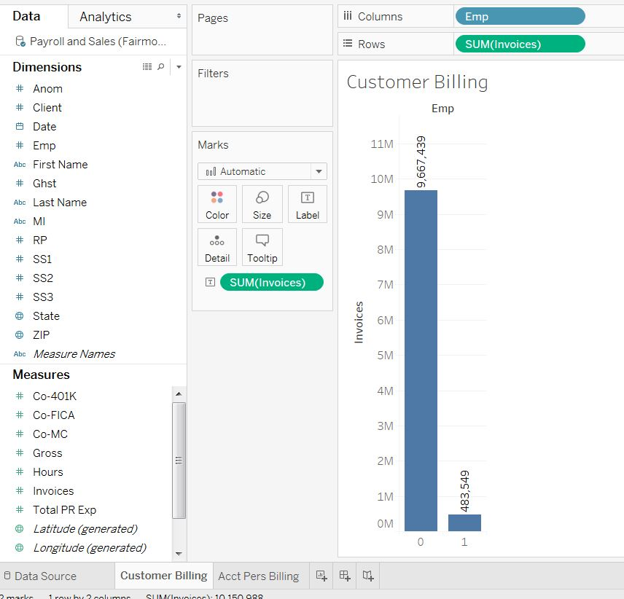

1. Right click on the “Customer Billing” worksheet (near the bottom) and copy the sheet
2. Click on the “Duplicate” (Sheet 2) worksheet and rename to “Acct Pers Client Billing”
3. Right-click on the taller “Emp” = 0 Columns and click on “Exclude”
4. Drag the “Client” Dimension to the Columns shelf

Student Task: Students should discuss the findings and recommend investigative next steps.

The results (solution):



Two clients appear to have been inappropriately billed for payroll associated with accounting personnel. Both of these clients, 10002 for $304,753 and 10008 for $178,797, have complained in the past about high billings. Because the forensic audit is not yet complete, the client should not yet be contacted. However, the sales manager and CEO who have interacted with the client related to billing should be alerted.