Appendix 02A
Least-Squares Regression Computations

True / False Questions
1. | The R² (i.e., R-squared) is a measure of the goodness-of-fit in least-squares regression.  True False

2. | When analyzing a mixed cost, you should always plot the data in a scattergraph, but it is particularly important to check the data visually on a scattergraph when the R² from a least squares regression is low. A quick look at the scattergraph can reveal that there is little relation between the cost and the activity or that the relation is something other than a simple straight line.  True False

Multiple Choice Questions
3. | _________________ is a method of separating a mixed cost into its fixed and variable elements by fitting a line to the data that minimizes the sum of the squared errors.  A. Account analysis  B. Scattergraph  C. High-low  D. Least-square regression

4. | Your boss would like you to estimate the fixed and variable components of a particular cost. Actual data for this cost over four recent periods appear below.  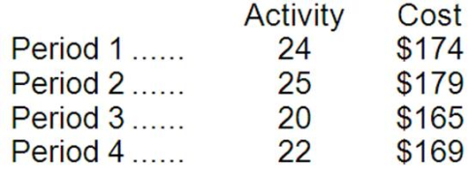  Using the least-squares regression method, what is the cost formula for this cost?  A. Y = $0.00 + $7.55X  B. Y = $110.44 + $2.70X  C. Y = $103.38 + $3.00X  D. Y = $113.35 + $0.89X

5. | The management of Bandle Corporation would like for you to analyze their repair costs, which are listed below:  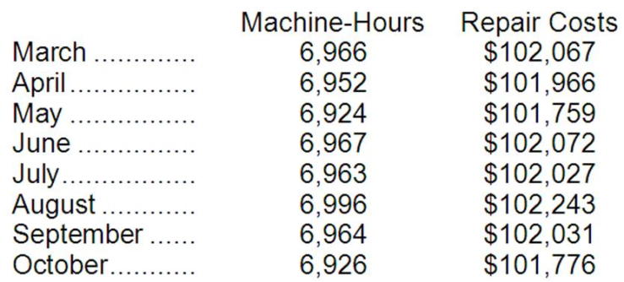  Management believes that repair cost is a mixed cost that depends on the number of machine-hours. Using the least-squares regression method, the estimates of the variable and fixed components of repair cost would be closest to:  A. $6.72 per machine-hour plus $55,230 per month  B. $6.80 per machine-hour plus $54,679 per month  C. $7.28 per machine-hour plus $51,389 per month  D. $14.66 per machine-hour plus $101,993 per month

6. | Laborn Inc.'s inspection costs are listed below:  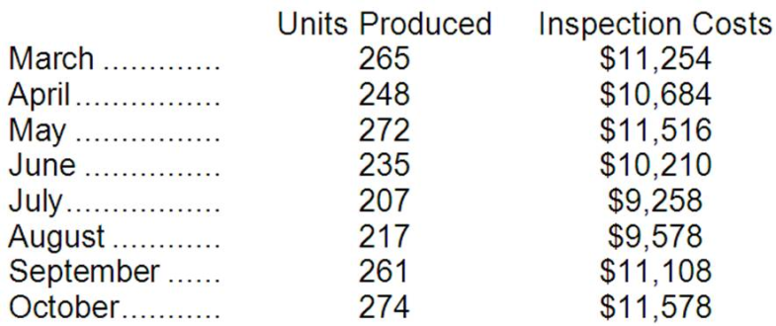  Management believes that inspection cost is a mixed cost that depends on the number of units produced. Using the least-squares regression method, the estimates of the variable and fixed components of inspection cost would be closest to:  A. $43.04 per unit plus $10,648 per month  B. $34.63 per unit plus $2,089 per month  C. $34.78 per unit plus $2,044 per month  D. $36.00 per unit plus $1,714 per month

Donner Company would like to estimate the variable and fixed components of its maintenance costs and has compiled the following data for the last five months of operations.
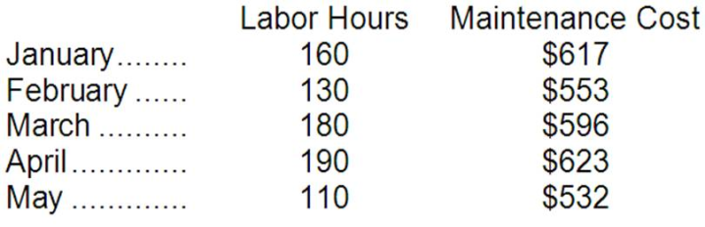

7. | Using the high-low method of analysis, the estimated variable cost per labor hour for maintenance is closest to:  A. $0.83  B. $1.84  C. $1.30  D. $1.14

8. | Using the high-low method of analysis, the estimated total fixed cost per month for maintenance is closest to:  A. $440  B. $407  C. $470  D. $0

9. | Using the least-squares regression method, the estimated variable cost per labor hour for maintenance is closest to:  A. $1.88  B. $1.52  C. $1.09  D. $1.96

10. | Using the least-squares regression method, the estimated total fixed cost per month for maintenance is closest to:  A. $470  B. $416  C. $400  D. $378

11. | Using the least-squares regression equation, the total maintenance cost for March is:  A. above the regression line.  B. on the regression line.  C. below the regression line.  D. outside the relevant range.

Recent maintenance costs of Gallander Corporation are listed below:
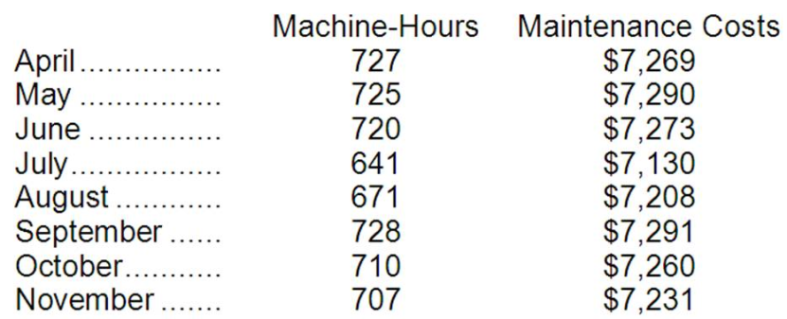
Management believes that maintenance cost is a mixed cost that depends on machine-hours.

12. | Using the least-squares regression method, the estimate of the variable component of maintenance cost per machine-hour is closest to:  A. $1.85  B. $10.30  C. $1.67  D. $1.90

13. | Using the least-squares regression method, the estimate of the fixed component of maintenance cost per month is closest to:  A. $6,066  B. $7,244  C. $5,944  D. $7,130

Cespedes Inc.'s inspection costs are listed below:
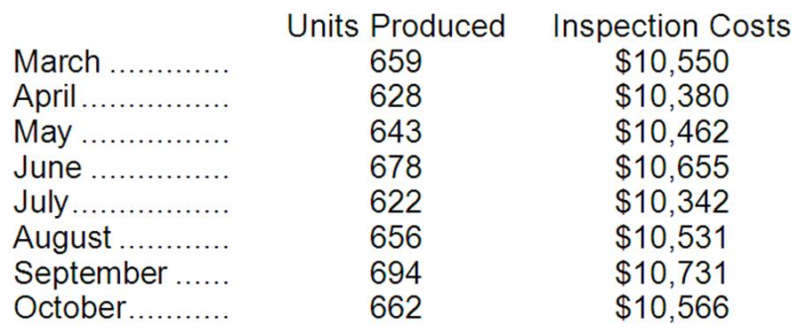
Management believes that inspection cost is a mixed cost that depends on units produced.

14. | Using the least-squares regression method, the estimate of the variable component of inspection cost per unit produced is closest to:  A. $5.40  B. $5.33  C. $5.43  D. $16.07

15. | Using the least-squares regression method, the estimate of the fixed component of inspection cost per month is closest to:  A. $6,983  B. $10,342  C. $10,527  D. $6,972

Essay Questions
16. | CPE for CPAs, Inc., provides continuing professional education for certified public accountants. The company is relatively new and management is seeking information regarding the company's cost structure. The following information has been gathered for the first six months of the current year:  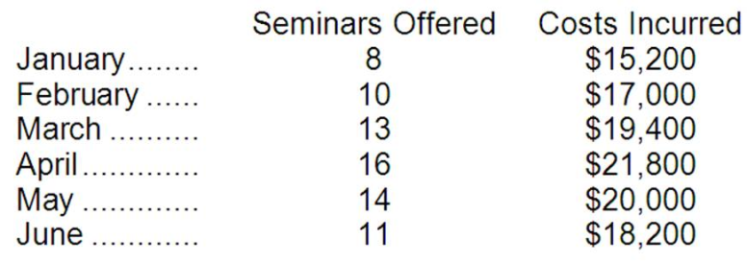  Required:  a. Using the high-low method, estimate the variable cost per seminar and the total fixed cost per month.  b. Using the least-squares regression method, estimate the variable cost per seminar and the total fixed cost per month.

17. | The management of Buff Sports Stadium believes that the number of sporting events each month is an measure of activity for total clean-up cost. Shown below are event figures and total clean up costs for the past four months:  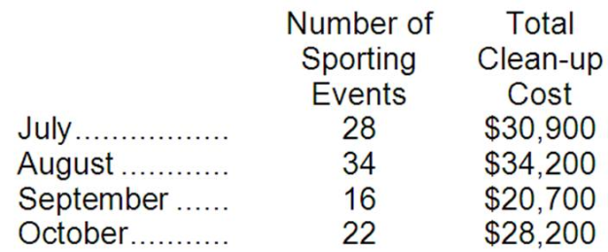  Required:  a. Estimate Buff's cost formula for monthly clean-up cost using the high-low method.  b. Estimate Buff's cost formula for monthly clean-up cost using the least-squares regression method.

