Chapter 1

Econometrics

There are no exercises or applications in Chapter 1.

Example 1.2
import$
Year, X,C
2000, 8559.4, 6830.4
2001, 8883.3, 7148.8
2002, 9060.1, 7439.2
2003, 9378.1, 7804.0
2004, 9937.2, 8285.1
2005, 10485.9, 8819.0
2006, 11268.1, 9322.7
2007, 11894.1, 9826.4
2008, 12238.8, 10129.9
2009, 12030.3, 10088.5
plot
;lhs=x
;rhs=c
;limits=6500,10500
;endpoints=8500,12500
;grid
;regression
;vaxis=Personal Consumption;Footer=Personal Income
;Title=Figure 1.1 Aggregate U.S. Consumption and Income Data, 2000-2009$
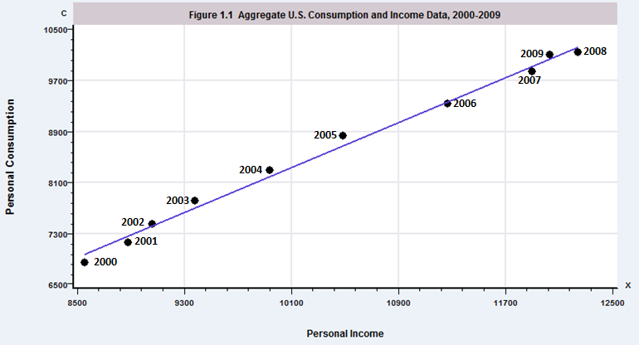
(Dates were added to the figure by editing.)

Chapter 2

The Linear Regression Model

There are no exercises or applications in Chapter 2.

Example 2.1. Keynes’s Consumption
import$
Year X C W
1940 241 226 0
1941 280 240 0
1942 319 235 1
1943 331 245 1
1944 345 255 1
1945 340 265 1
1946 332 295 0
1947 320 300 0
1948 339 305 0
1949 338 315 0
1950 371 325 0
plot;lhs=x;rhs=c;limits=200,350; endpoints=225,375;regression
;title=Figure 2.1 Consumption Data, 1940-1950 $
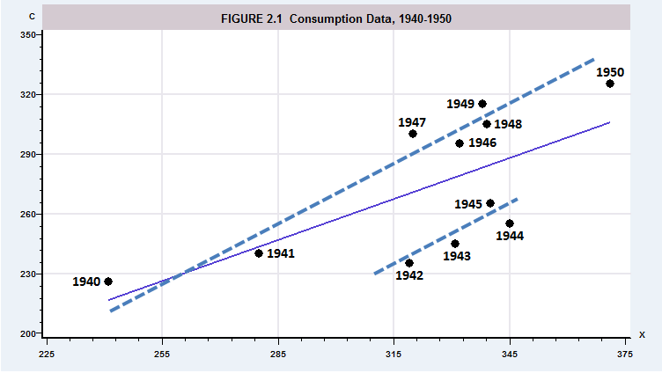
(Dates and dashed lines were added by editing.)

Example 2.7. Nonzero Conditional Mean of the Disturbances
